**Session**

Doubt session

**Agenda**

Doubt Clearing Session of Last 2 Weeks.

**Exercise**

***1. Explain SQL Mode in MySQL and set NO_ENGINE_SUBSTITUTION SQL NO_ENGINE_SUBSTITUTIONMode for MySQL from MySQL Shell and from the conf file as well.***

The MySQL server can operate in different SQL modes, and can apply these modes differently for different clients, depending on the value of the sql_mode system variable. DBAs can set the global SQL mode to match site server operating requirements, and each application can set its session SQL mode to its own requirements.

Modes affect the SQL syntax MySQL supports and the data validation checks it performs. This makes it easier to use MySQL in different environments and to use MySQL together with other database servers.

Setting NO_ENGINE_SUBSTITUTION Mode From MySQL Shell

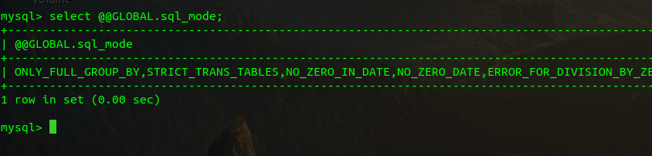

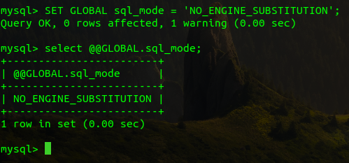

Setting NO_ENGINE_SUBSTITUTION Mode from conf file

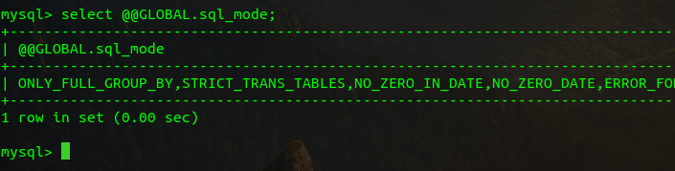

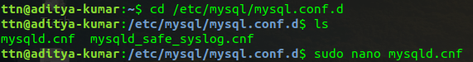

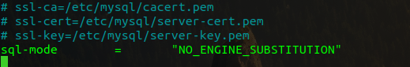



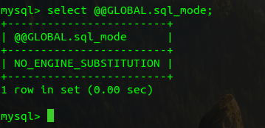

***2. Create a bash script to write current CPU and Memory of your laptop to a file and put that script as a system service.***

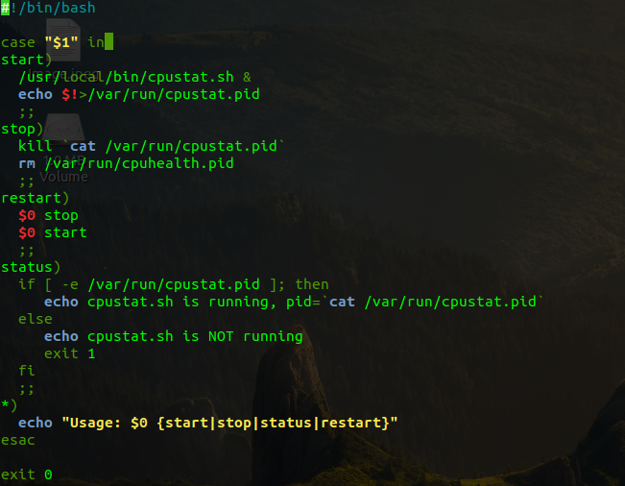

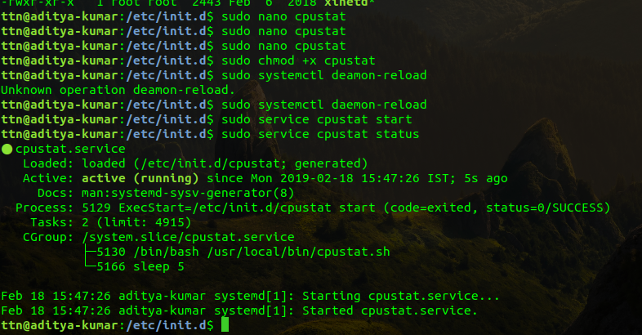

***Cpustat.sh file***

***output***

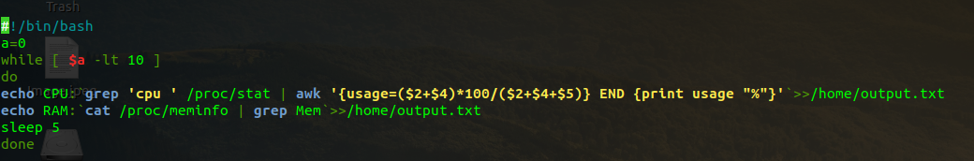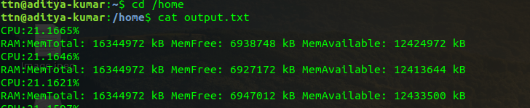

***3. Create a sample script which should run on system shutdown.***

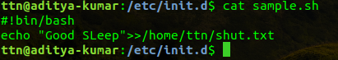

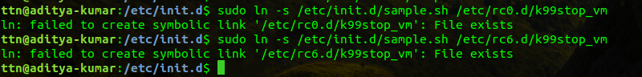

**

*After restart*

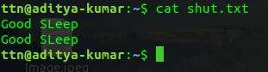

***4. Run 2 sample java war file from tomcat and proxy pass the request from nginx to both tomcats in the round robin.***

*Code in tomcat8 server.xml*

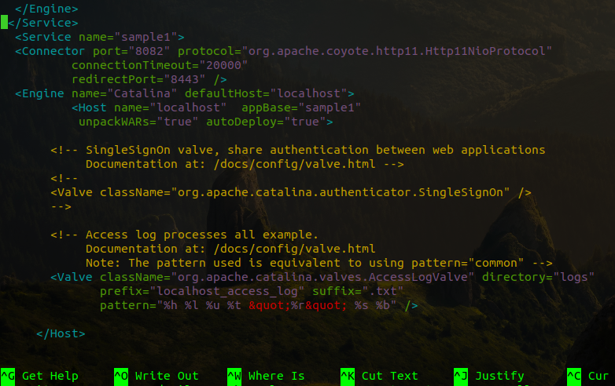

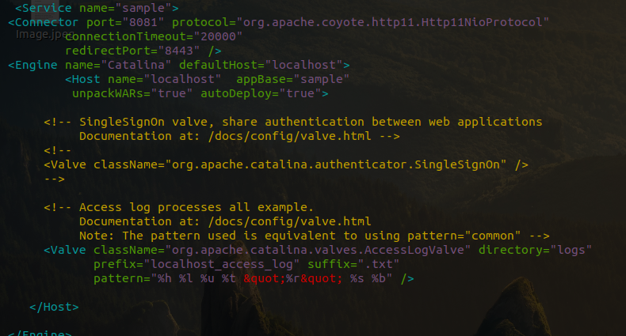

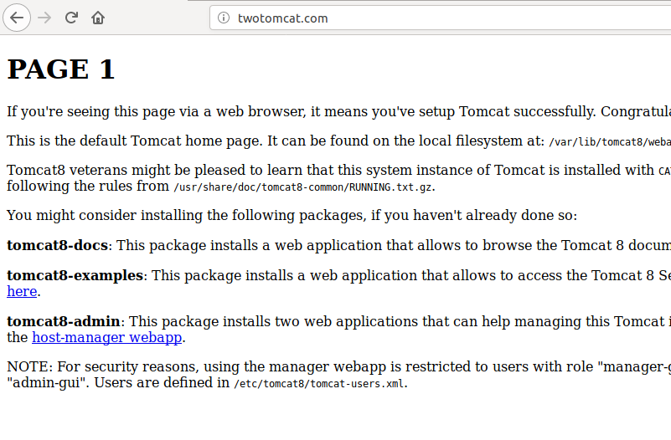

*When refreshed again it redirects to page 2*

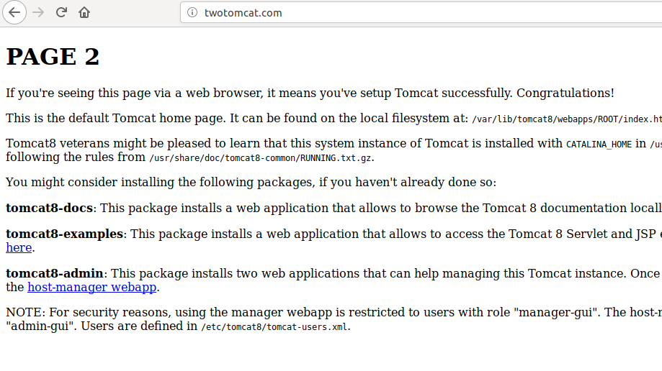

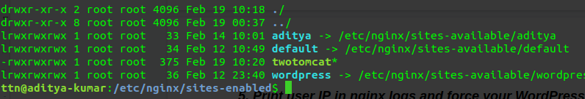

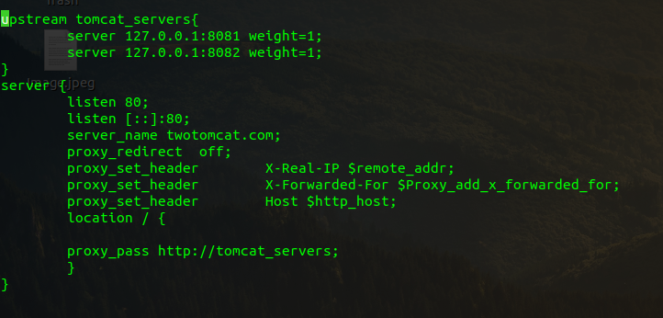

***5. Print user IP in nginx logs and force your WordPress admin portal to be open from a certain IP only.***

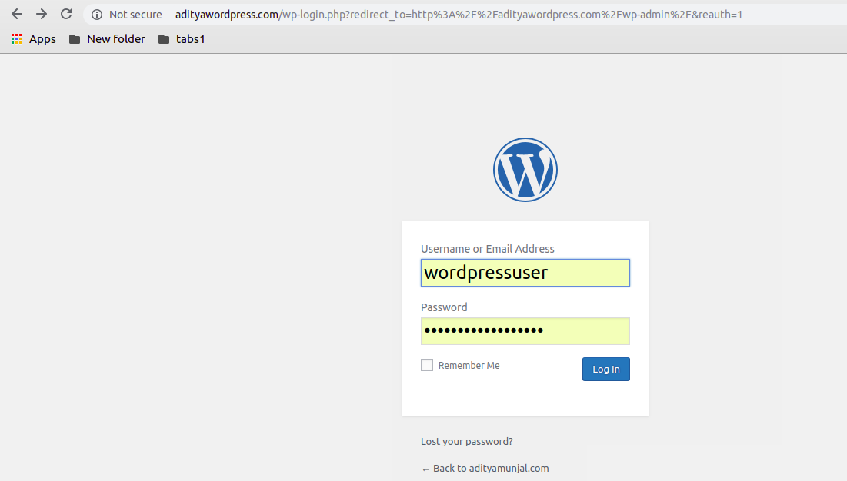

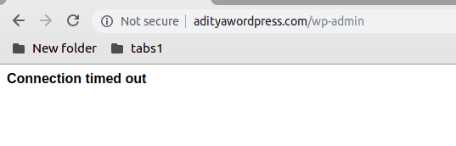

Inside sites-enabled

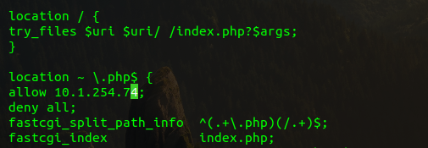

In etc/hosts  
